1. Sample Dataset (Student Marks)
RegNo | Name | Dept | Marks
101 | Arun | CSE | 78
102 | Bala | IT | 65
103 | Chitra | CSE | 82
104 | Deepa | ECE | 74
105 | Eshan | IT | 90
106 | Farah | CSE | 69
107 | Gokul | ECE | 85
108 | Hari | IT | 73
109 | Isha | CSE | 88

2. Create Dataset in R
RegNo <- c(101,102,103,104,105,106,107,108,109)
Name <- c("ARUN","BALA","CHITRA","DEEPA","ESHAN","FARAH","GOKUL","HARI","ISHA")
Dept <- c("CSE","IT","CSE","ECE","IT","CSE","ECE","IT","CSE")
Marks <- c(78,65,82,74,90,69,85,73,88)
student <- data.frame(RegNo,Name,Dept,Marks)
print(student)

Output
RegNo Name Dept Marks
1 101 ARUN CSE 78
2 102 BALA IT 65
3 103 CHITRA CSE 82
4 104 DEEPA ECE 74
5 105 ESHAN IT 90
6 106 FARAH CSE 69
7 107 GOKUL ECE 85
8 108 HARI IT 73
9 109 ISHA CSE 88

3. Mean, Median, Mode, IQR in R

Mean

print(mean(student$Marks))

78.222

Median

print(median(student$Marks))

78

Mode

print(table(student$Marks))

65 69 73 74 78 82 85 88 90

1 1 1 1 1 1 1 1 1

IQR

print(IQR(student$Marks))

65 69 73 74 78 82 85 88 90

1 1 1 1 1 1 1 1 1

Quartiles

print(quantile(student$Marks))

0% 25% 50% 75% 100%

65 73 78 85 90

4. Bar Chart (Department wise count)
barplots <- barplot(table(student$Dept),border="green",main="Department wise count",xlab="Departments",
ylab="no of students",col="red",cex.lab=2,col.lab="red",cex.main=2,col.main="yellow")
print(barplots)
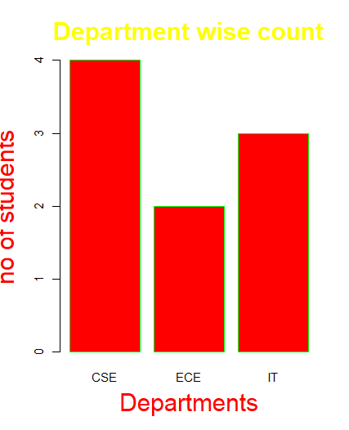

5. Pie Chart
piechart <- pie(table(student$Dept),col=c("red","blue","green"),main="Department Distribution",main.cex=2,main.col="yellow")
print(piechart)
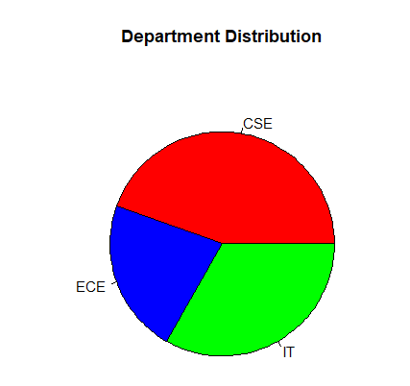

6. Histogram (Marks Distribution)
histchart <- hist(student$Marks, col = "lightgreen", border = "black", main = "Distribution of Student Marks",xlab = "Marks",ylab = "Frequency",
cex.main = 1.5, col.main = "darkblue", font.main = 2, cex.lab = 1.2,col.lab = "darkred", font.lab = 2)
print(histchart)
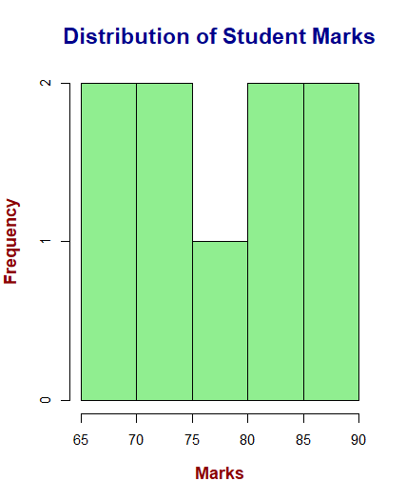

7. Density Plot
densityplot <- plot(density(student$Marks), col="blue", lwd=2, main="Density Plot of Marks", col.main="darkblue", cex.main=1.5, font.main=2, xlab="Marks", ylab="Density", col.lab="darkred", cex.lab=1.2, font.lab=2)
print(densityplot)

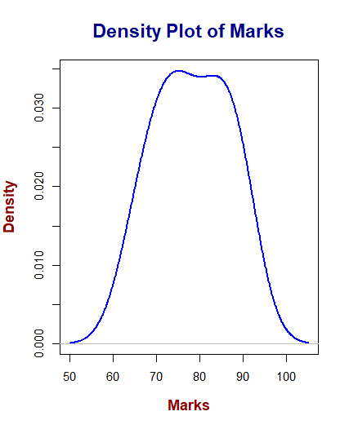

8. Boxplot
boxplot <- boxplot(student$Marks, col="orange", border="black", main="Boxplot of Marks", xlab="Marks", ylab="Marks", col.main="darkblue", cex.main=1.5, font.main=2, col.lab="darkred", cex.lab=1.2, font.lab=2)
print(boxplot)
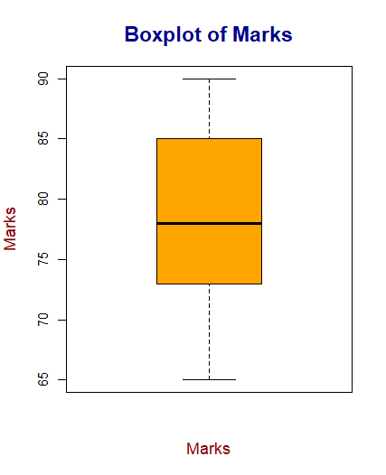

9. Scatter Plot
scatterplot <- plot(student$RegNo, student$Marks, col="red", pch=19, main="Scatterplot of RegNo vs Marks", xlab="Register Number", ylab="Marks", col.main="darkblue", cex.main=1.5, font.main=2, col.lab="darkred", cex.lab=1.2, font.lab=2)
print(scatterplot)

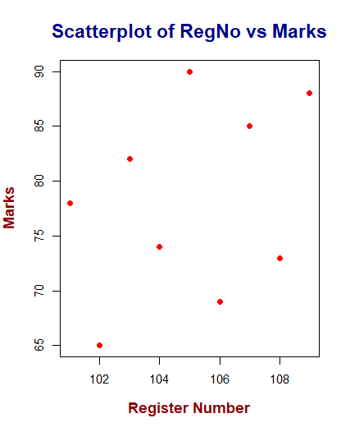

10. Line Chart
linechart <- plot(student$Marks, type="l", col="purple", lwd=2, main="Line Chart of Marks", xlab="Student Index", ylab="Marks", col.main="darkblue", cex.main=1.5, font.main=2, col.lab="darkred", cex.lab=1.2, font.lab=2)
print(linechart)
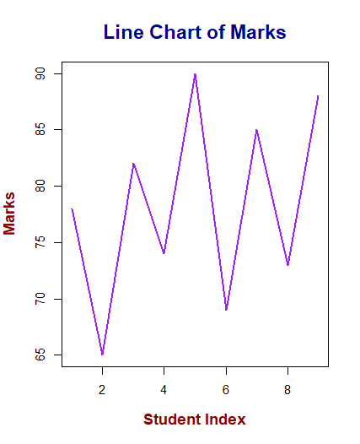

11. Practice Questions (Using Above Data)

1. Department Strength Analysis
The college administration wants to see how many students belong to each department to plan classroom allocation.
Question:
Draw a suitable chart in R to show the number of students in each department.
dept_count <- table(student$Dept)
barplt <- barplot(dept_count, col=c("skyblue","orange","lightgreen"), border="black", main="Number of Students by Department", xlab="Department", ylab="Number of Students")
print(barplt)
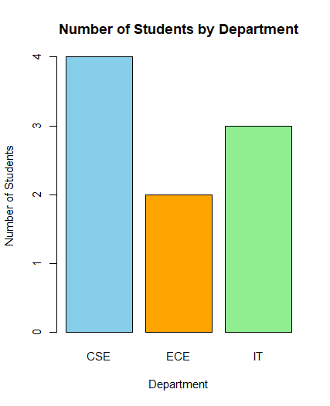
2. Marks Distribution Analysis
The examination committee wants to understand how marks are distributed among students to check whether the exam was easy or difficult.
Question:
Create a chart in R to display the distribution of marks.
histplt <- hist(student$Marks, col="lightgreen", border="black", main="Distribution of Marks", xlab="Marks", ylab="Frequency")
print(histplt)
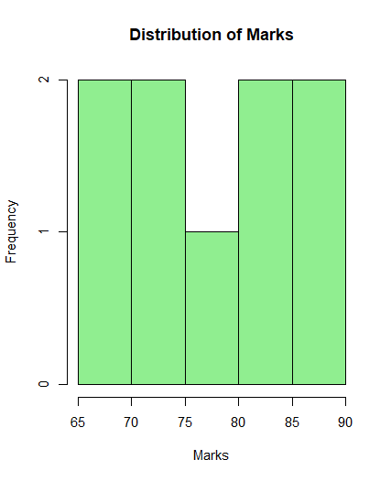

3. Marks Trend Monitoring
A teacher wants to observe how marks vary across student registration numbers to detect performance trends.
Question:
Draw a chart in R showing the trend of marks across students.
lineplt <- plot(student$RegNo, student$Marks, type="l", col="purple", lwd=2, main="Marks Trend Across Students", xlab="Registration Number", ylab="Marks")
print(lineplt)

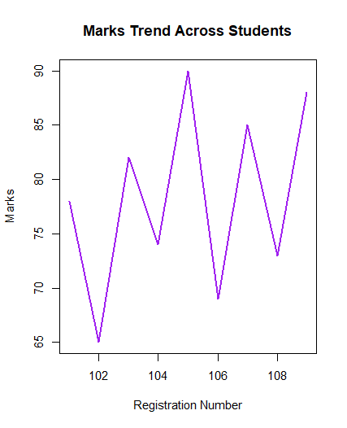

4. Outlier Detection
The academic coordinator wants to identify whether any student marks are unusually high or low compared to others.
Question:
Create a chart in R that helps detect outliers in marks.
boxplt <- boxplot(student$Marks, col="orange", border="black", main="Boxplot of Marks", xlab="Marks", ylab="Marks")
print(boxplt)

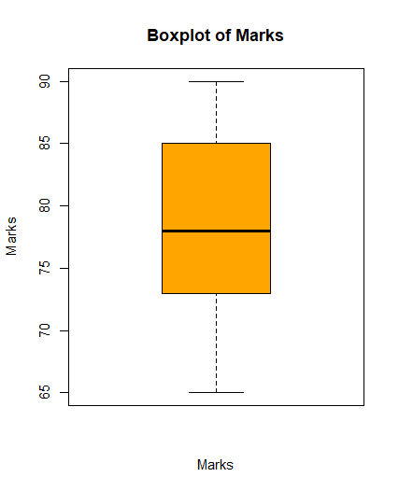

5. Relationship Analysis
The department wants to check if there is any pattern between student registration number and marks scored.
Question:
Plot the relationship between RegNo and Marks using R.
scatterplt <- plot(student$RegNo, student$Marks, col="red", pch=19, main="RegNo vs Marks", xlab="Registration Number", ylab="Marks")
print(scatterplt)
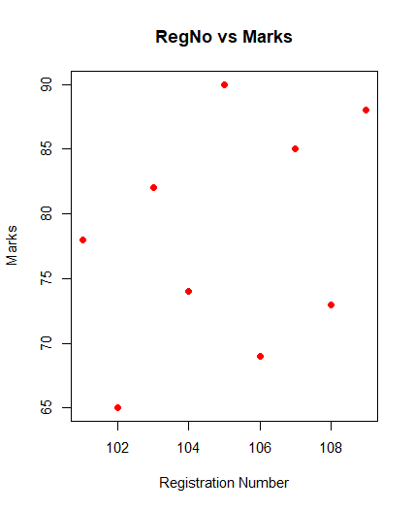

6. Department Percentage Analysis
The management wants to see the percentage contribution of each department in the class.
Question:
Create a chart in R to display the percentage of students in each department.
dept_count <- table(student$Dept)
pieplt <- pie(dept_count, col=c("skyblue","orange","lightgreen"), main="Department-wise Percentage")
print(pieplt)
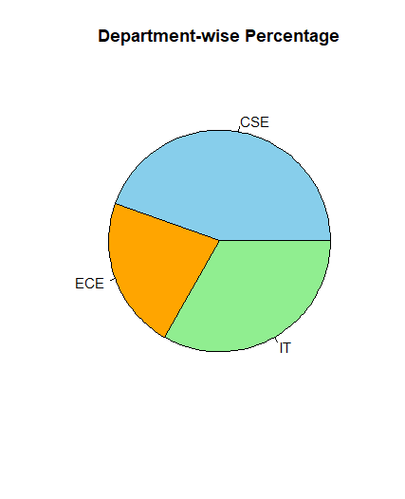

7. Performance Density Study
A data analyst wants to study the smooth distribution pattern of marks to understand the probability of student performance levels.
Question:
Draw a chart in R showing the density distribution of marks.
densityplt <- plot(density(student$Marks), col="blue", lwd=2, main="Density Plot of Marks", xlab="Marks", ylab="Density")
print(densityplt)
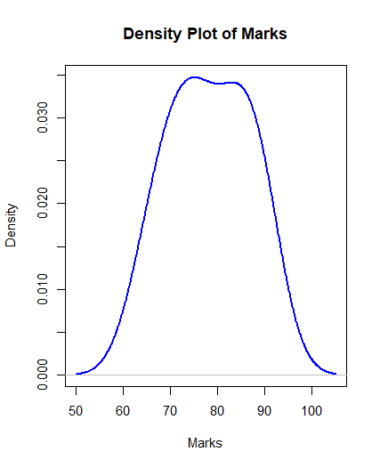

8. Comparative Performance Study
A teacher wants to compare student marks distribution visually to understand overall performance spread.
Question:
Create a suitable visualization in R to summarize the marks distribution using quartiles.
boxplt <- boxplot(student$Marks, col="orange", border="black", main="Marks Distribution by Quartiles", xlab="Marks", ylab="Marks")
print(boxplt)
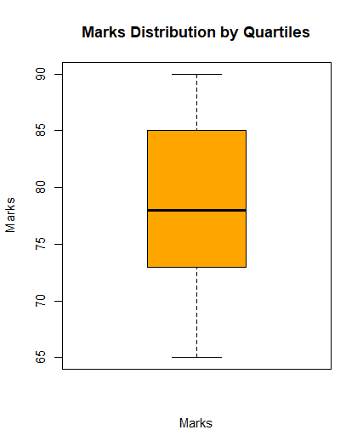

9. Department vs Marks Visualization
The HOD wants to compare marks scored by students across different departments.
Question:
Draw a chart in R that compares marks among departments.
dept_boxplt <- boxplot(Marks ~ Dept, data=student, col=c("skyblue","orange","lightgreen"), main="Marks by Department", xlab="Department", ylab="Marks")
print(dept_boxplt)

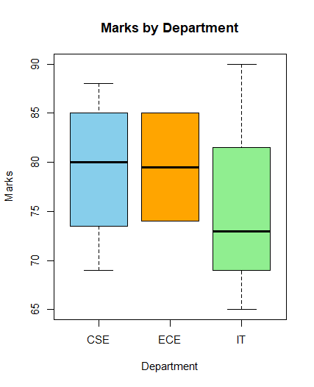

10. Student Performance Overview
The college principal wants a quick visual summary of student marks for a presentation.
Question:
Generate a simple visualization of student marks using R.
marks_barplt <- barplot(student$Marks, names.arg=student$RegNo, col="steelblue", border="black", main="Student Marks", xlab="Registration Number", ylab="Marks")
print(marks_barplt)
